

Name: Saim Nisar
Class: ADCS 2 A
Roll no: 2500626
Subject: Web Technologies

Lab Task 1:
<head>
<meta charset="UTF-8">
<meta name="viewport" content="width=device-width, initial-scale=1.0">
<title>Document</title>
<link rel="stylesheet" href="style.css">
</head>

</head>

<body>

<nav class="navbar">
<h2 class="logo">PORTFOLIO</h2>

<ul class="nav-links">
<li><a href="#">Home</a></li>
<li><a href="#">About</a></li>
<li><a href="#">Services</a></li>
<li><a href="#">portfolio</a></li>
<li><a href="#">page</a></li>
<li><a href="#">contact</a></li>
</ul>

<button class="nav-btn">Get Free Consultant</button>
</nav>

<div id="divs">
<h3>GET EVERY SINGLE SOLUTIONS.</h3>
<h1><b>I'm Designer</b></h1>
<h1><b>Haris F. Watson</b></h1>
<p>Mt name is saim nisar.I am a web developer and also Expert in html and Css.I am also a video editor .<br></p>
<div id="buttons"> <button><b>Learn More</b></button></div>
<div id="press"> <button><b>Hire Me</b></button></div>
</div>
<img src="C:\Users\2500618\Downloads\images.jpg" alt="bg image">
</body>
</html>

CSS
body {
background-image: url("C:\Users\2500618\Downloads\images.jpg");
background-size: cover;
background-position: center;
background-repeat: no-repeat;
background-color:rgb(203, 219, 233);
}

#divs{
padding:100px;
margin-top: 200px;
}

.divs{
display:flex;

}
#buttons button{
background-color: rgb(44, 4, 4);
border-radius: 5px;
color:white;
padding:10px 30px;
border-color: rgb(124, 77, 77);
margin-top: 20px;
transition:0.3s;
}
#press button{
background-color: rgb(255, 255, 255);
border-radius: 5px;
color:rgb(22, 13, 13);
padding:10px 45px;
border-color: rgb(255, 255, 255);
margin-left: 150px;
position:relative;
top:-39px;
transition:0.3s;
}
h1{
color:rgb(2, 56, 105);

}
h3{
color:rgb(241, 136, 171);
}
#buttons button:hover{
transform:scale(1.1);
background-color:rgb(250, 73, 73);
}
#press button:hover{
transform:scale(1.1);
background-color: black;
color:white;
}
.navbar{
display: flex;
justify-content: space-between;
align-items: center;
padding: 20px 80px;
background-color: rgb(255, 255, 255);
}

.logo{
color: rgb(2, 56, 105);
}

.nav-links{
list-style: none;
display: flex;
gap: 30px;
}

.nav-links li a{
text-decoration: none;
color: black;
font-weight: 500;
}

.nav-links li a:hover{
color: rgb(243, 94, 94);
}

.nav-btn{
background-color: rgb(243, 94, 94);
color: white;
padding: 10px 25px;
border: none;
border-radius: 5px;
transition:0.3s;
}
.nav-btn:hover{
transform:scale(1.1);
}

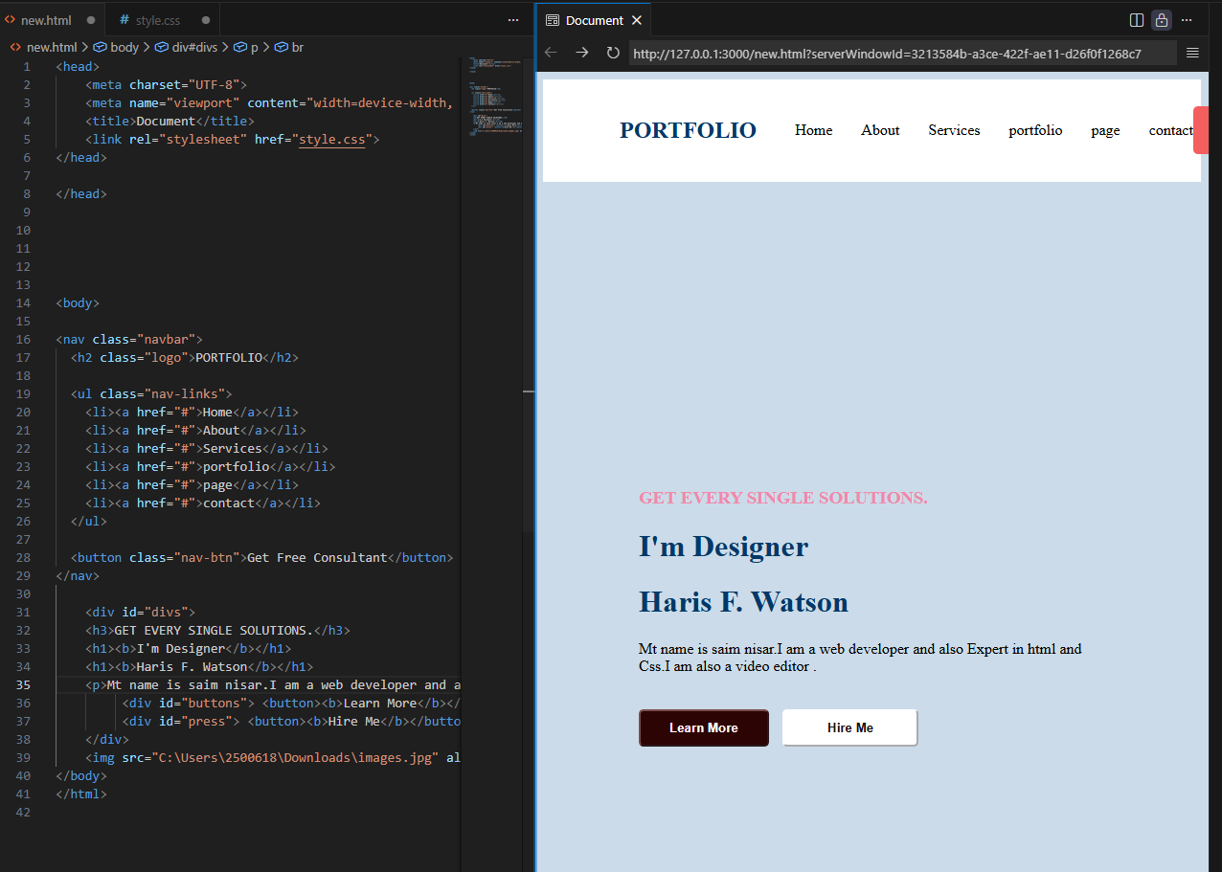

Lab Task 2

<!DOCTYPE html>
<html>
<head>
<title>Simple Product Page</title>
<link rel="stylesheet" href="style.css">
</head>
<body>

<div class="card">
<div class="Image">
<img src="https://encrypted-tbn0.gstatic.com/images?q=tbn:ANd9GcRX15sn8mdMhHqkx3VpFvbk5mkJ0YOC_ZXVQg&s" >
</div>
<h1>Wireless watch</h1>
<p>This is the very beautiful watch.You can buy it and enjoy its features.
</p>
<div class="Price"><b>78$</b></div>
<div class="button">
<button>Buy Now</button>
</div>
</div>

</body>
</html>

CSS

body {
background-color: white;
display: flex;
justify-content: center;
align-items: center;
min-height: 100vh;

}
.card{
background-color:rgb(231, 218, 218);
width: 250px;
text-wrap: inherit;
padding: 20px;
border-radius: 10px;
transition: 0.6s;

}
.card:hover{

transform:scale(1.1);
}
.Image{
padding:10px;
width: 10px;
}
.Price{
text-rendering: auto;

}
.button button{
background-color: green;
align-items: center;
color: aliceblue;
padding: 10px 20px;
border-radius: 10px;
cursor: pointer;
display:block;
margin:10px auto;
transition: 0.3s;

}
.button button:hover{
background-color: darkgreen;
transform:scale(1.1);
}

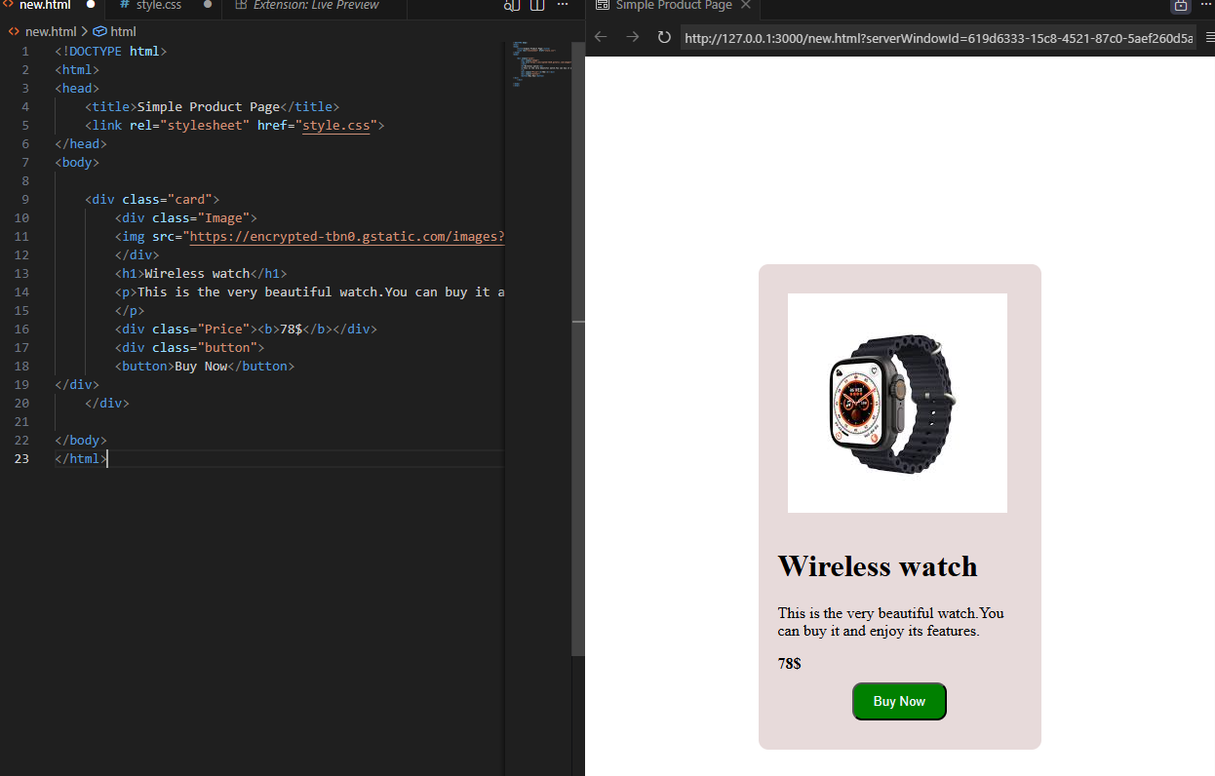
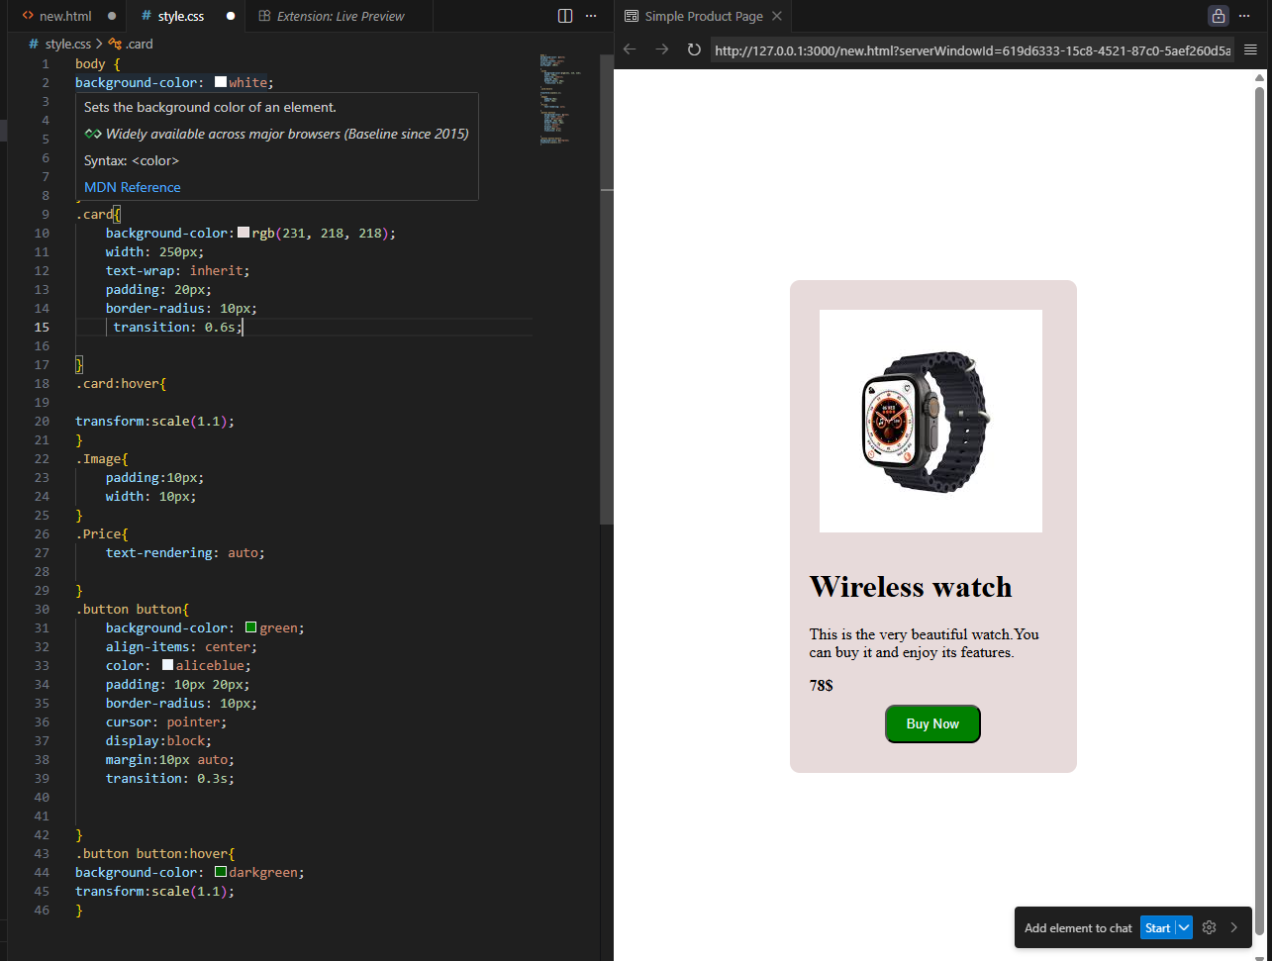

Lab Task 3

<!DOCTYPE html>
<html lang="en">
<head>
<meta charset="UTF-8">
<title>Sign In / Register</title>
<link rel="stylesheet" href="style.css">
</head>
<body>

<div class="login-card">
<h2>Create Account</h2>
<form>
<input type="text" placeholder="Full Name" class="input-field">
<input type="email" placeholder="Email Address" class="input-field">
<input type="password" placeholder="Password" class="input-field">
<input type="password" placeholder="Confirm Password" class="input-field">

<button type="submit" class="login-btn">Sign Up</button>
</form>

<p class="footer-text">Already have an account? <a href="login.html">Login</a></p>
</div>

</body>
</html>

CSS

body {
background-color: #2c3e50;
display: flex;
justify-content: center;
align-items: center;
min-height: 100vh;
margin: 0;
font-family: 'Segoe UI', sans-serif;
}

.login-card {
background-color: white;
padding: 35px;
border-radius: 15px;
box-shadow: 0 10px 25px rgba(0,0,0,0.3);
width: 320px;
text-align: center;
}

.input-field {
width: 100%;
padding: 12px;
margin: 8px 0;
border: 1px solid #ddd;
border-radius: 25px;
outline: none;
box-sizing: border-box;
transition: 0.3s;
}

.input-field:focus {
border-color: #3498db;
}

.login-btn {
width: 100%;
padding: 12px;
background-color: darkcyan;
color: white;
border: none;
border-radius: 25px;
cursor: pointer;
font-size: 16px;
margin-top: 15px;
transition: 0.3s;
}

.login-btn:hover {
background-color: #2ecc71;
transform: translateY(-2px);
}

.footer-text {
margin-top: 20px;
font-size: 14px;
color: #666;
}

.footer-text a {
color: #3498db;
text-decoration: none;
font-weight: bold;
}

